PROJECTPHASE2

DATAFLOWDIAGRAM&USERSTORIES

|  |  |
| --- | --- |
| **DATE** | **4NOV2022** |
| **TEAMID** | **PNT2022TMID26869** |
| **PROJECTNAME** | **IOTBASEDSMARTWASTEMANAGEMENTMETROPOLITIESCITYS** |
| **MAXIMUMMARKS** | **4Marks** |

# DataFlowDiagrams:

A Data Flow Diagram (DFD) is a traditional visual representation of the information flows within a system. A neat and clear DFD can depict the rightamount of the system requirement graphically. It shows how data enters and leaves the system, what changes the information, and where data isstored.

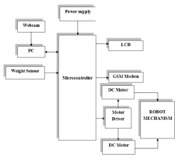

# UserStories

|  |  |  |  |  |  |  |
| --- | --- | --- | --- | --- | --- | --- |
| **UserType** | **FunctionalRequirement(Epic)** | **User StoryNumber** | **UserStory/Task** | **Acceptancecriteria** | **Priority** | **Release** |
| Authorised Person(Manages  webapp) | Login | USN-1 | As an authorized person, I gave user id and password for every workers and manage them. | I can access web page  /dashboard | Medium | Sprint-2 |
| Admin | checking | USN-2 | As a admin, I will manage garbage level monitor. When garbage gets filling alert, I will post location and garbage Id to trash truck. | I can manage garbage monitoring. | High | Sprint-1 |
| TruckDriver | Login | USN-3 | As a driver ,I’ll follow the route sent by user to reach the filled garbage location. | I can drive to reach the garbage location | Medium | Sprint-2 |
| Garbage Collector | collecting | USN-4 | As a garbage collector, I’ll collect all the garbage fromgarbage bin and load it to the truck and send them tolandfill. | I can collect garbage and pulled to truck. | Medium | Sprint-2 |
| Municipality | Login | USN-5 | As a municipality, I’ll check the process are happening indiscipline manner without any issues. | I can manage all the process going good. | High | Sprint-1 |